**NAME – KARAN DAS**

**USER ID – 34763**

**MAIL-** [**karannnx20@gmail.com**](mailto:karannnx20@gmail.com)

**Date – 13th Aug 2025**

**Topic Assignment:**

**1. Process Check and Delete**

In PowerShell, we can check if a process is running and then stop (delete) it.

# Check process

Start-Process -Name "notepad" -Wait

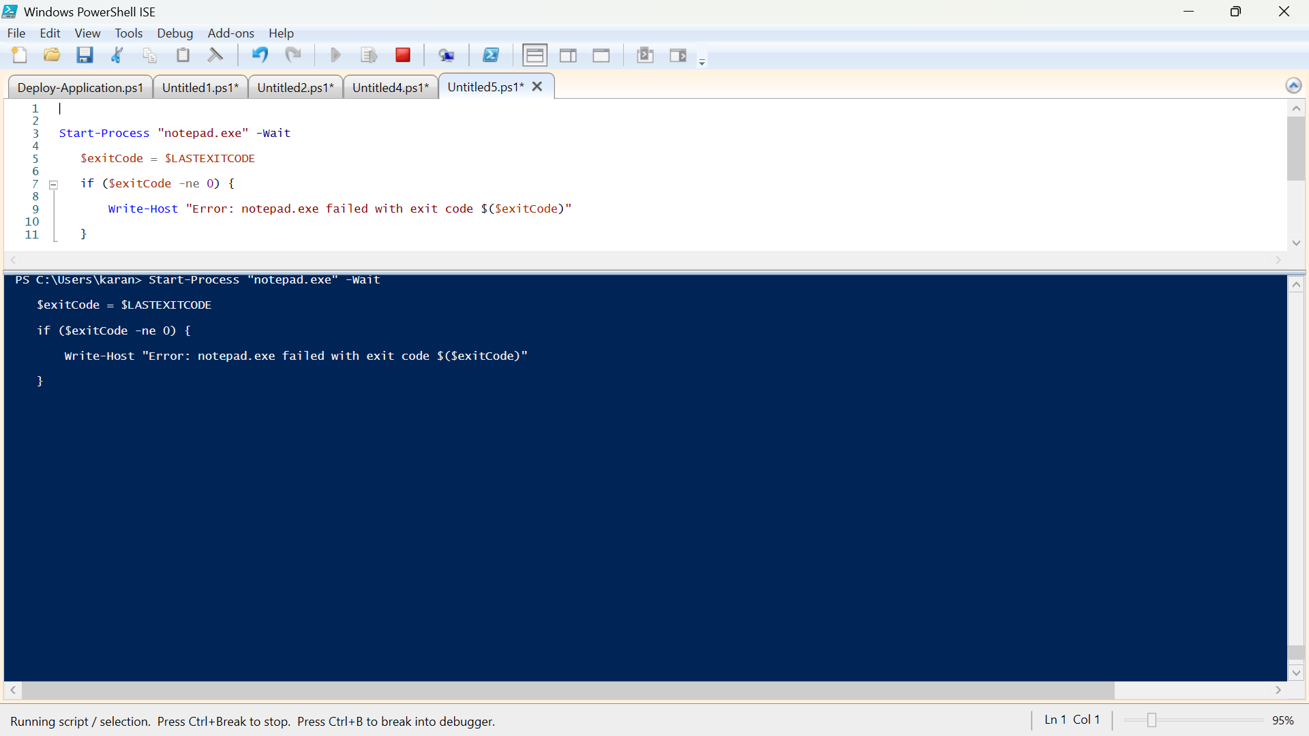

# Stop process

Stop-Process -Name "notepad" -Force

**2. Loop-based Scripting Operations**

Loops let you repeat actions multiple times until a condition is met.

Example: For loop

for ($i = 1; $i -le 5; $i++) {

Write-Host "Loop number $i"

}

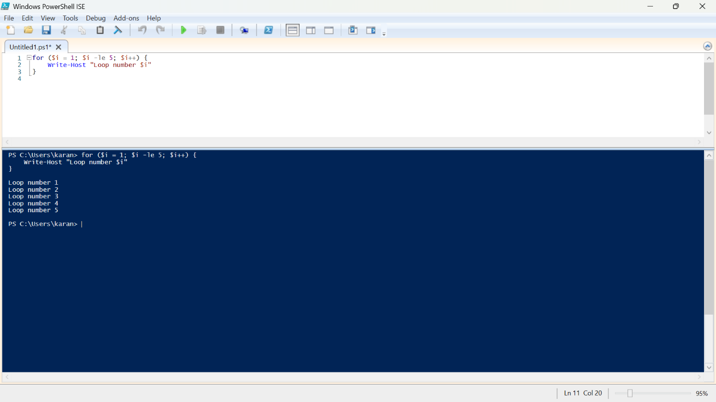

Example: Foreach loop

$apps = "Chrome","Edge","Notepad++"

foreach ($app in $apps) {

Write-Host "Installing $app"

}

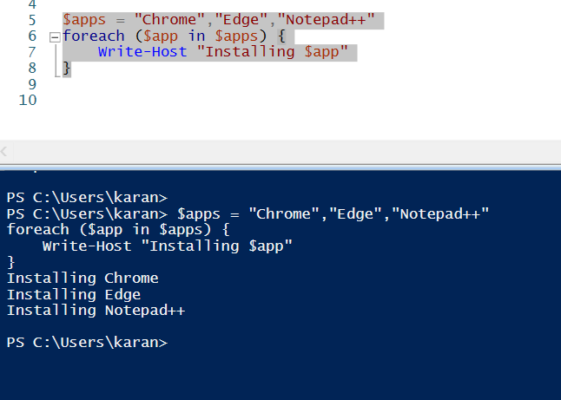

**3. Set-Ini Value**

PSAppDeployToolkit has a function to update .ini files:

Set-IniValue -FilePath "C:\Config\settings.ini" -Section "General" -Key "Language" -Value "EN"Purpose: Change application settings before or after install.

**4. Toolkit Logging Location and How It’s Configured**

PSAppDeployToolkit logs are usually stored in:

C:\Windows\Logs\Software

Location is set in AppDeployToolkitConfig.xml.

Example XML snippet:

<LogPath>C:\Windows\Logs\Software</LogPath>

We can change it to a custom path if needed.

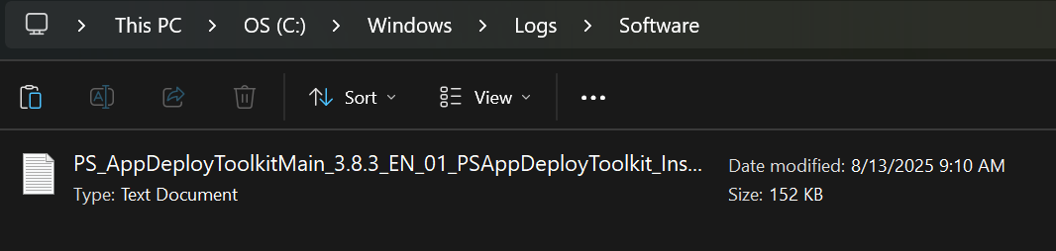

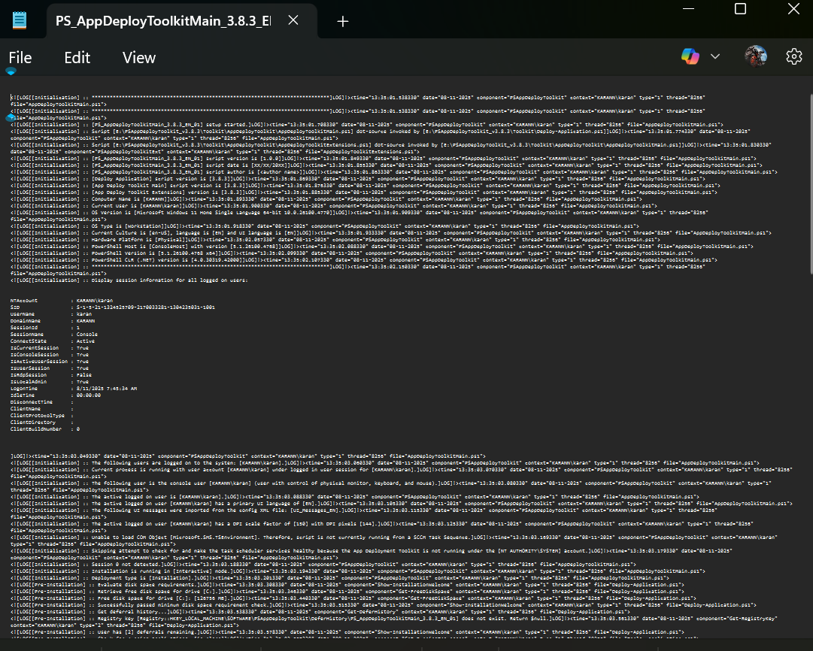

5. MSI/MSP Logging

MSI = Windows Installer package.

MSP = Windows Installer patch.

Enable logging in PowerShell:

6. Individual Command Logging within Script

You can log specific actions in your script:

Write-Output "Starting Chrome installation" | Out-File "C:\Temp\myscript.log" -Append

Or in PSAppDeployToolkit:

Write-Log "Starting installation of Chrome"

7. How to Catch Return Codes in PowerShell

Return codes tell you if a command succeeded (0) or failed (non-zero).

$process = Start-Process "msiexec.exe" -ArgumentList '/i app.msi /qn' -Wait -PassThru

if ($process.ExitCode -eq 0) {

Write-Host "Installation successful"

} else {

Write-Host "Installation failed with code $($process.ExitCode)"

}

